Kaa'Reth

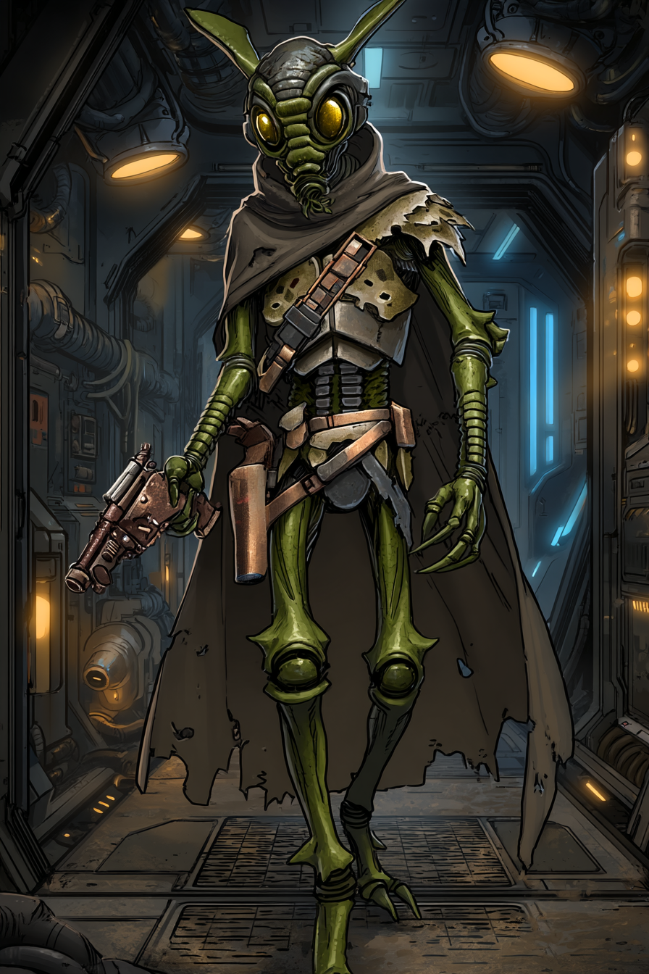
The Roche asteroid hives sang with electromagnetic radiation. Every Verpine heard it. Most learned to filter it. Background noise to their natural radio communication. Kaa'Reth learned to parse it. Every signal was information. Every transmission left traces. The hive's elders called it useless curiosity. Kaa'Reth called it listening to the galaxy's heartbeat.
He left the hives at seventeen. Not exiled. Not fleeing. Simply following signals to their sources. Trading posts had more interesting data streams than asteroid colonies. Planets had networks that sprawled across continents. The galaxy was drowning in information and nobody was listening properly.
His first job was debugging a merchant's inventory system. Simple work. Boring work. But the merchant's system connected to port authority databases. Which connected to shipping registries. Which connected to Imperial customs protocols. Kaa'Reth traced the connections. Mapped the networks. Learned how the Empire's digital bureaucracy functioned.
Knowledge became profitable. A smuggler needed shipping manifests altered. A rebel cell needed communication protocols that hid inside normal traffic. A corporation needed their competitor's bid documents. Kaa'Reth provided solutions. Clean. Elegant. Untraceable.
The mutualist convoy job was different. Personal. Three ships carrying medical supplies to refugee camps. The Empire had flagged them for contraband inspection. The scan data was fabricated. Kaa'Reth recognized the digital signature of the forgery. Someone was using Imperial authority to steal humanitarian aid.
He cracked the customs node in fifteen seconds. Deleted the flag. Cleared the convoy. Started covering his tracks. Not fast enough. ISB counterintrusion protocols activated. They had his signal pattern. They had his location. They would have him in minutes.
His compound eyes tracked three screens simultaneously. Escape routes. Pursuit vectors. Digital countermeasures. All failing. Then the node flooded with data. Thousands of false transactions. Ghost ships that never existed. Cargo that was never loaded. The ISB trace died in the noise.
A single message appeared before deleting itself: "Clean exit. Good work on the convoy. Kestrel appreciates precision."
Kaa'Reth ran. Changed ships at three ports. Switched identities twice. Paid cash for everything. The message found him anyway. New ship. New identity. Same text: "Your intrusion signature is catalogued. ISB will find you eventually. Alternative: work for me. I keep your signal clean. You crack systems that matter."
The decision took 0.7 seconds. Survival probability alone was worth accepting. The ISB did not forgive. Did not forget. Did not stop hunting. Kestrel offered camouflage. Protection. Purpose.
The jobs were surgical. A medical database hiding biological weapons research. An Imperial supply depot routing food away from refugees. A financial system funding unofficial detention centers. Always targets that deserved cracking. Always information that needed freeing.
After eight months, Kestrel made an offer: "YT-1300 crew needs technical specialist. Mobile platform. Stable cover. Your kind of work."
The crew was eclectic. Tekli, the Chadra-Fan pilot who had modified his ship into something beautiful and illegal. Bill, the young Zabrak who moved like a soldier but claimed to be a dockworker. Both had secrets. Both had reasons to avoid the Empire. Kaa'Reth understood secrets. Understood reasons.
He established protocols immediately. Clean documentation for every port. Rotating transponder codes that passed inspection. Encrypted channels for crew communication. Digital hygiene that kept them boring to automated systems. The Empire tracked anomalies. Kaa'Reth ensured they remained statistical noise.
When Ragath joined, the crew dynamics stabilized. Four specialists. Different skills. Same goal: stay free, help others do the same. They ran Kestrel's jobs. Moved supplies that mattered. Stayed ahead of Imperial algorithms.
Kaa'Reth mapped every system they passed through. Built databases of Imperial protocols. Learned which checkpoints used outdated scanners. Which ports had corrupted records. Which routes had gaps in surveillance. Information was survival. Survival was everything.
The courier mission briefing came through triple-encrypted channels. Black-site navigation data. Prison transport routes. Classification levels that should not exist. The courier would carry it all in a secured nav-core. Kaa'Reth's job: extract the data, sanitize Imperial records, leave no trace they had ever been there.
Payment was hardware. A shard-key access to a Rebel relay. Verpine-grade quantum processors. The kind the hives reserved for queens and military coordinators. The kind that could crack Imperial encryption in real-time instead of hours. The kind that turned a good slicer into a digital ghost.
Kaa'Reth ran probability calculations. Success: 67.3% with current resources. Failure: imprisonment or termination. The hardware would improve his capabilities by orders of magnitude. Would let him protect the crew better. Would let him find his hive-sister who had been pressed into Imperial service.
His sister had always been the better engineer. The Empire noticed. Offered contracts. Made it clear refusal would impact the entire hive. She accepted. Her messages stopped six months ago. Official records said she was on assignment. Unofficial channels said nothing. She had vanished into the Empire's machinery.
With Verpine-grade hardware, he could find her. Could trace her through classified networks. Could possibly extract her. Could at least know if she lived. The uncertainty was worse than knowing she was dead. Uncertainty meant hope. Hope meant distraction. Distraction meant mistakes.
The YT-1300 flew toward the rendezvous. Kaa'Reth prepared his tools. Digital lockpicks. Virtual skeleton keys. Programs that made Imperial encryption look like children's puzzles. Everything tested. Everything ready.
He touched the screens in his cabin. Data flowed like water. Like music. Like the electromagnetic songs of his home hives. But louder. More complex. The galaxy's heartbeat was accelerating. War was coming. Not the obvious war between Empire and Rebellion. Something deeper. Something in the data streams that should not exist.
Kaa'Reth would crack the courier's nav-core. Would take the black-site data. Would learn what the Empire was hiding. Would find his sister. Would keep his crew flying free. Would listen to the galaxy's secrets and remember them all.
The Verpine had perfect memory. It was their gift. Their curse. Kaa'Reth remembered every line of code he had ever written. Every system he had ever cracked. Every secret he had ever learned. Soon he would have more secrets. More memories. More weapons against an Empire that thought information could be controlled.
Information wanted to be free. Kaa'Reth would ensure it found its freedom. One cracked system at a time.

